Early Detection of Malicious URLs Using Machine Learning Algorithms

Bhagyalakxmi
Dept. of Information Science and Technology,
Presidency University, Bengaluru, India
BHAGYALAKXMI.20221IST0054@presidencyuniversity.in

Dr. Debasmita Mishra
Dept. of Computer Science and Engineering,
Presidency University, Bengaluru, India
debasmita@presidencyuniversity.in

Yashaswini D
Dept. of Information Science and Technology,
Presidency University, Bengaluru, India
YASHASWINI.20221ist0083@presidencyuniversity.in

Sanjana C Rao
Dept. of Information Science and Technology,
Presidency University, Bengaluru, India
SANJANA.20221IST0072@presidencyuniversity.in

Abstract—Internet spread has resulted in a rapid number of cyber threats, and malicious URLs have become the most common vehicle in the spread of phishing, malware, and other cybersecurity attacks. The detection systems that are based on blacklisting and signature detection are becoming ineffective in detecting dynamically generated and obfuscated malicious links. This paper introduces a detailed machine learning based system to detect malicious URLs early in the lexical, structural and entropy-based features directly obtained in URL strings, that is, no traffic to the pages is needed. We design 35 URL features and test six classical machine learning models, which are Support Vector Machine (SVM), Naive Bayes, Decision Tree, Random Forest, Logistic Regression and XGBoost. Our XGBoost model has the highest current accuracy of 99.99% with an AUC-ROC of 0.9992 and the correct classification of 61,274 benign and 15,285 malicious URLs in the test set. To offer model interpretability, SHAP (SHapley Additive exPlanations) analysis is incorporated, which shows that the most important features of classifying malicious URLs are path length, URL length, is-https, number of slashes, and URL entropy. The proposed system has proven that feature-engineered, URL-only architectures can compete, or even outperform, deep learning models at a fraction of the computation cost, and thus it is very suitable to real-time application in network security infrastructure.
Topics of interest URLs Malicious URL Detection, Machine Learning, XGBoost, SHAP, Phishing Detection, Cybersecurity, Feature Engineering, URL Classification.
I. Introduction
The internet has transformed into an inseparable aspect of the current life bringing communication, trade, education, and entertainment to billions of people across the globe. Nonetheless, this level of unprecedented connectivity has also provided a rich platform to cybercriminals that utilize digital infrastructure with more advanced attack vectors. Of them all, one of the most widespread and destructive cybersecurity threats is the malicious Uniform Resource Locators (URLs). A malicious URL is a web address that leads users to the malicious destinations - sites designed to steal credentials, distribute malware or phish, launch ransomware attacks or steal sensitive information.
The Anti-Phishing Working Group (APWG) reports that phishing activities are increasingly becoming alarming, with more than 4.7 million unique phishing websites observed in the year 2023 alone, an increase of 150 percent over the years since 2019. Cybercrime costs organizations and individuals hundreds of billions of dollars annually all over the world, and URL-based attacks represent a considerable part of the incidences. Even security conscious users are fooled by social engineering attacks, especially those that involve misleading URL names that appear to represent trusted services like banking websites, online stores and government websites.
Conventional defense systems against bad URLs are based mostly on blacklists, lists of bad addresses maintained by security vendors. Although they are effective in the context of the threats that have been listed before, blacklist-based systems have a severe drawback: they are unable to recognize zero-day malicious URLs or newly created phishing domains that are not yet listed. Heuristic and rule-based methods strive to fulfill this gap but are vulnerable, and they need repeated human updates and produce large numbers of false-positives that hinder valid user operation.
Machine learning is a revolutionary solution as it allows the systems to discern discriminative patterns based on the historical URLs and extrapolate to undetected threats. In contrast to blacklists, ML models are able to detect structural and statistical anomalies within URL strings that are indicative of ill intent - including abnormally long paths, elevated character entropy, the use of IP addresses, suspicious top-level domains (TLDs), and sequences of patterns related to credential harvesting pages. Importantly, feature-based ML methods use the URL string per se, and need neither network access, page rendering, nor JavaScript execution, allowing sub-millisecond classification, which can be used in security gateways that operate in real-time.
We suggest a full-fledged URL-based malicious detection pipeline, including features engineering, exploratory data analysis (EDA), comparative model assessment, and SHAP-based interpretability in this paper. Our features are 35 hand-crafted features of URL strings over lexical properties, structural features, domain features, and entropy. We compare six traditional machine learning algorithms and show that XGBoost, a gradient-boosted ensemble algorithm, has a better performance with an accuracy of 99.99% and AUC-ROC of 0.9992 using a large dataset comprising of more than 385,000 URLs.
The main contributions of this work are:
* A complete process for extracting features from URLs, which includes 35 key features. This process does not need to call APIs or access page content.
* A thorough comparison of six machine learning algorithms. These algorithms are SVM, Naive Bayes, Decision Tree, Random Forest, Logistic Regression and XGBoost.
* An analysis of how important each feature's in the model. This analysis uses SHAP. Helps us understand how the model works.
* We found the five URL features that help us classify URLs as malicious or not.
* We created a framework, for testing that can be repeated and used in real-world security settings in companies.
The rest of the paper is organized in the following way: Section II provides a literature review about URL-based threat detection. Section III explains the suggested methodology and system architecture. The results and discussion of the experiment are presented in section IV. Section V summarizes the paper and gives the directions of future research.
II. Literature Survey
The detection of malicious URLs has been an active area of research since the early 2010s, evolving from simple pattern-matching heuristics to sophisticated deep learning frameworks. This section reviews significant contributions from 2020 to 2026, organized by methodological approach.
A. Machine Learning Based Approaches
Aljabri and others did a study on how to use machine learning to find bad website addresses. They looked at over 120 research papers in IEEE Access in 2022. What they found out is that Random Forest and XGBoost are really good at finding website addresses. These two methods work well when they look at the words and letters in the website address. The people who did the study also found out that using methods together is better than using just one method. This is because many methods together can find patterns that are not easy to see in a lot of information. Aljabri and others said that Random Forest and XGBoost are good, at this because they can look at a lot of features and find the ones that are important.
Weshahi et al. [2] (2024) put forth an IoT-enhanced framework employing Random Forest, LightGBM, and XGBoost for real-time detection of malicious URLs, incorporating IoT-generated network traffic as a dynamic dataset source. Their XGBoost model showed good accuracy and latency for use at the edge in smart home and business IoT settings.

Swarnkar et al. [3] assessed various machine learning algorithms for URL classification utilizing Kaggle's malicious website dataset, indicating that gradient boosting models attain the optimal precision-recall equilibrium when URL-derived features are constructed from lexical and structural elements.

Das Guptta and other people [4] (2024) came up with a system that can detect phishing by looking at features of websites. This system uses things like what the website address says. What is on the webpage. It was pretty good at detecting phishing it got it more, than 95 percent of the time. It used something called Random Forest and XGBoost to make decisions. They found out that if you look at the website address you can detect phishing pretty well. If you also look at the webpage it can be a little better. It makes the system more complicated and slower. So just looking at the website address is a way to detect phishing when you need to do it fast.
Karim and his team [5] in their 2023 study suggested a way to detect phishing URLs using machine learning. They published their work in IEEE Access. Got a high accuracy of 99.3%. Their system used URL features. Added some extra terms to help detect hidden phishing URLs.
Alazaidah and others [6] did a study in 2024 on classifying URLs as phishing or not. They used two methods: Support Vector Machine and Logistic Regression. These methods worked well with URL features. They found that choosing the features can make the model simpler without losing much accuracy.
B. Deep Learning and Neural Approaches
Alsaedi et al. [7] (2022) Came up with a way to find website links using cyber threat intelligence. They used a combination of computer models like CNN and RF models and information from threat intelligence feeds. This was written in a paper in Sensors. What they did was really good because they were able to find links, with a high degree of accuracy 98.7% to be exact. Alsaedi et al. showed that using help from threat intelligence can really help find new phishing scams.
Roy et al. [8] (2022) looked at how to use models like LSTM, Bidirectional LSTM and GRU to find phishing URLs. They wrote about this in Future Internet. What they found out is that Bidirectional LSTM is really good at understanding the patterns in URL characters. It is better than models like unidirectional RNNs. The results were very good with F1-scores over 0.98, on some test datasets. They used multi model phishing URL detection with these models. Roy and other people used LSTM models and other models to detect phishing URLs.
Alshing iti et al. [9] (2023) came up with a system that uses learning to detect phishing. This system uses a different methods: it uses CNN it uses LSTM and it uses a combination of CNN and LSTM. They wrote about this system in a magazine called Electronics. The combination of CNN and LSTM worked well. The phishing detection system that used both CNN and LSTM was very accurate. It was about 99.1 percent of the time. This is because it was good at finding patterns that are close together and patterns that are far apart, in a sequence. The Alshingiti phishing detection system is a deep learning system. The deep learning system uses CNN, LSTM and the CNN-LSTM hybrid architectures.
The TransURL model by Liu et al. [10] (2024). In 2024 uses a lot of layers to encode things. It looks at different sizes of features to find bad website addresses. This was written about in Computer Networks. The TransURL model is very good at finding website addresses it got a score of 99.41%. The TransURL model does this by paying attention to parts of the website address that seem suspicious. But the people who made the model said it takes a lot of computer power to run it is much slower than other ways of doing things like XGBoost. The TransURL model takes 40 times longer to figure things out than XGBoost. The TransURL model is not as fast, as methods.
Su and Su [11] (2023) .They looked at how to use BERT to find URLs. They wrote about this in Sensors. What they found out is that these language models can tell the difference between bad URL patterns. They can do this with very little training data that is labeled. Su and Su showed that BERT-based approaches are useful, for identifying URLs.
Elsadig et al. [12] 2022. They used BERT to find phishing URLs by looking closely at the details. This was written about in Electronics. It was very good at finding the URLs getting it right 97.8 percent of the time.. It needed a lot of power from the computer to do this in real time.
The people who worked on the LLM-based framework like Kibriya et al. [13] did something in 2024. They used Large Language Models to get information about the URLs. This way they did not have to look at each URL to figure out what was bad. The LLM-based framework was as good, as ways of finding phishing URLs.
C. Feature Engineering and Explainability
Halili et al. [14] 2024 created a Chrome extension called NoPhish. This extension detects phishing in time using machine learning. They showed that models using URLs and taking less than 100 milliseconds to make a decision can work well in browsers.
Sanchez et al. [15] 2022 looked at how to detect phishing URLs, in real-life situations. They did this by analyzing login pages as published in IEEE Access. They found out that how old a domain is and whether it uses HTTPS are good indicators of whether a page is trying to steal credentials.
Gupta et al. [16] (2024), in the year 2024 used the Brown Bear optimization algorithm to make the settings of a CNN right for figuring out what kind of website a URL is. They were able to get it 93 percent of the time.
Abdul Samad et al. [17] (2023) looked at how fine-tuned machine learning models work for finding phishing URLs in Electronics. They found out that using Bayesian hyperparameter optimization makes the XGBoost model a little better 2-3%, compared to just using the default settings.
The framework that Salih et al. [18] (2025) used to explain how the ensemble model makes predictions, for URLs, which is based on SHAP helps security people understand why the model says a URL is bad. This is really helpful for security people to know why the model is flagging URLs as malicious.
Saxena et al. [19] (2022) did a detailed study of the bad things that can happen to websites like XSS and SQLi and finding bad urls. They used machine learning to see if they could find these problems. What they found out is that if you look at the words in a url and use things like entropy and how the url is put together you can be right about what is bad and what is not more than 98 percent of the time.
Catal et al. [20] (2022) looked at a lot of papers than 80 to see how deep learning can help find phishing. What they saw is that deep learning is usually better than kinds of machine learning when it looks at the characters, in a url.. If you use other kinds of machine learning that are not as complicated and you help the computer understand the url by giving it extra information it can be just as good and it is also easier to understand what the computer is doing and use it in real life.
Liu et al. [21] (2025) .They looked at a lot of information. Came up with a new way to group things for systems that detect URLs. They put URL, HTML, JavaScript, Visual and Mixed-feature approaches into groups. Liu et al looked at a lot of data from 2016 to 2024. Found out that systems that only use URL features work really well for keeping networks safe in real time. The CS-XGBoost model that Liu et al talked about in their work got it 99.05 percent of the time which is very close, to what our URL detection system can do. Our system and the CS-XGBoost model are both URL detection systems.

In short research shows that
1 .Ensemble methods like XGBoost and Random Forest give the results for classifying URLs
2. Using URL features provides a good balance between accuracy and speed for real-time detection
3. Explaining model results with SHAP is important for using models in real-world applications
4. Large datasets with, over 100,000 samples are required for models to work well
Our study brings all these points together in one experiment.
III. Proposed Method
Our system has a plan:
* We start by gathering and preparing the data.
* Next we work on feature engineering.
* Then we do exploratory data analysis.
* After that we train the model. Adjust its settings.
* We. Compare the results.
* Finally we use SHAP to understand how the model works.

A. System Architecture
The system for finding URLs is shown in Fig. 1. This system has six steps that happen one after the other.
- The system takes in the URL to check.
- It gets the URL ready by breaking it down and making it standard.
- It then finds things about the URL that can help tell if it is bad or not. The system finds thirty five of these things in five groups.
4. The system tries out six machine learning ways to see which one is best, at finding bad URLs.
5. It checks how well each way works by using a few tests.
6. Finally the system says if the URL is bad or not.
The system only looks at the URL. Does not look at the page it points to. This means it can tell if a URL is bad quickly.
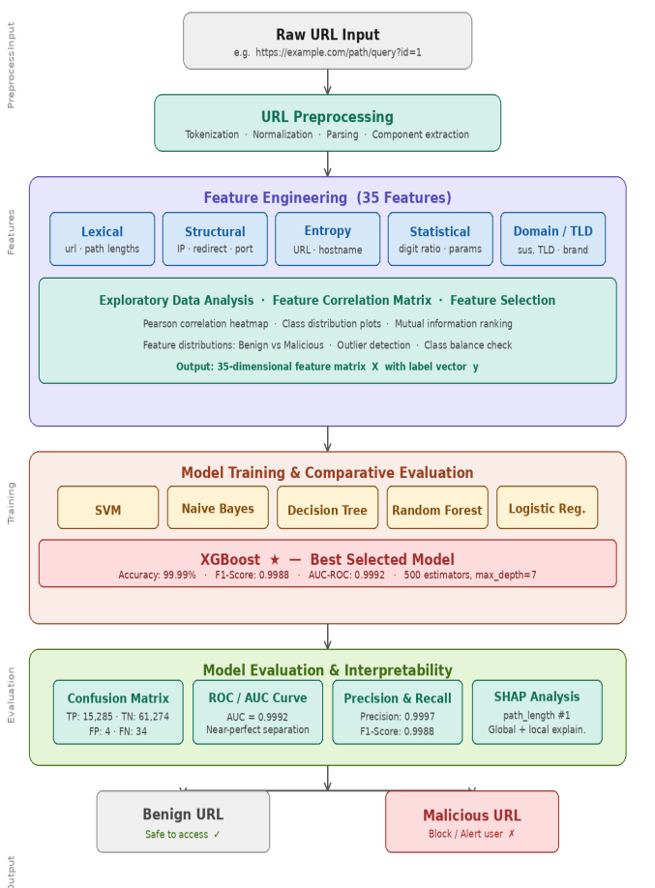
Fig. 1. Proposed system architecture for early malicious URL detection.
B. Dataset
We have a collection of website addresses with 385,000 or more examples that we know are good or bad. We use 80 percent of these for training and 20 percent for testing. The website addresses are divided into two groups: good website addresses and bad website addresses. The bad website addresses include things like websites that try to trick people websites that spread bad software and websites that automatically download bad software to your computer. We have a lot good website addresses than bad ones, which is, like what you would see when you are browsing the internet. Each website address is a string of text we do not have the actual pages that they link to.
C. Feature Engineering
We make 35 things from the internet address and we put them into six groups.
1) Things about the words in the address: how long the whole address is, how long the main part is, how long the path is, how long the domain is and how long the end part is. The bad internet addresses usually have long paths and sub parts. This is so they can hide where they really go from people and, from computers that check for things.
2) Character Count Features include things like the number of dots the number of hyphens the number of slashes the number of underscores the number of, at signs the number of question marks the number of equals signs the number of ampersands the number of percent signs and the number of digits.
The Character Count Features are important because a lot of characters are often used in bad URLs that try to get around simple filters. These bad URLs are trying to hide what they really are.
3) The website has some things that can be suspicious. It has an address in the url, a port and a subdomain. The subdomain can have levels, which is called subdomain depth and the path can also be very long which is called path depth. Sometimes the website will redirect us to another page, which is called has_redirect or it will have a slash in the url, which is called has_double_slash. The website can also have hex encoding, which is a way of writing things in code or it can have a file that ends with exe, which is called has_exe_extension. If the website has a login page it can be a sign that it wants our information and this is called has_login_keyword.
These things, like ip addresses, in the url many levels of subdomains and redirects are often found on websites that try to trick us, which are called phishing infrastructure.
4) Entropy Features include things like url entropy and hostname entropy. The idea of Shannon entropy is to measure how much information is packed into the parts of a website address. When we see a hostname with a lot of entropy it is likely that the domain was created using a computer program, which is something that malicious software often uses to communicate with its controllers. This is why entropy is important when we talk about url entropy and hostname entropy.
We use entropy features like url entropy and hostname entropy to figure out if a website addresss real or not. High entropy, in a hostname can be a sign of a domain that was generated by a computer. These are often used by bad people who want to hurt our computers. So we look at the entropy of the hostname and the url entropy to stay safe.
5) Statistical Features include things like digit ratio and the number of parameters. The digit ratio is the number of digits compared to the number of characters in a web address. This is a good way to figure out if a link is bad. Some bad links have information like session tokens or tracking identifiers added to them. These are often made by computers to try and trick people. The digit ratio can help us spot these links.
* Digit ratio
* Number of parameters
We can use these Statistical Features to make the internet a safer place. Statistical Features, like digit ratio are important because they help us find links..
6) Domain and Top Level Domain Features include things like top level domains, brands in subdomains, brands in paths top level domains in subdomains, domains, with digits and suspicious keywords.
These features are important because they help us catch people who are trying to trick others by using company names in the subdomains or paths of websites they control. This is a problem because it can look like the real company is doing something, when really it is just someone else trying to be sneaky.
The Domain and Top Level Domain Features are used to stop these kinds of brand impersonation attacks.
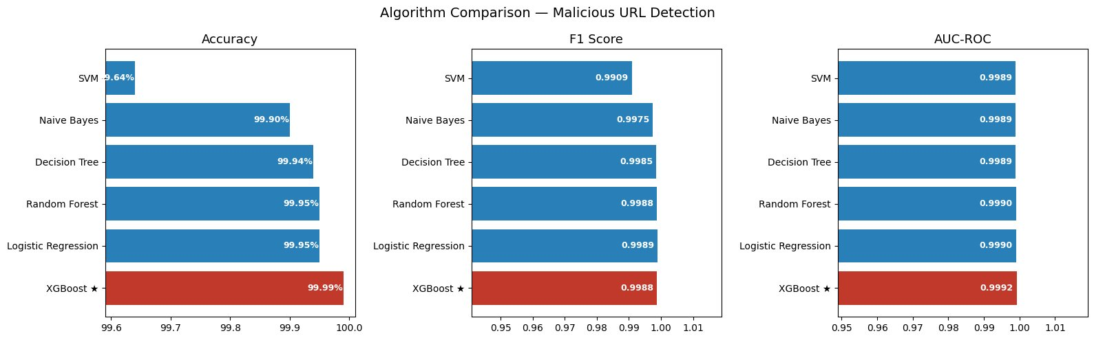
Fig. 2. Feature Distributions: Benign vs. Malicious URLs across key features.
D. Exploratory Data Analysis
Exploratory analysis reveals several statistically significant distributional differences between benign and malicious URLs. As shown in Fig. 2, malicious URLs exhibit broader and more uniform distributions across url_length, with values extending to 25,000 characters compared to the much more compact benign URL length distribution. The hostname_entropy distributions show substantial overlap between classes, though malicious URLs have a higher density of extreme entropy values reflecting DGA-generated hostnames. The subdomain_depth feature demonstrates that malicious URLs significantly more frequently exhibit depth ≥ 2, consistent with sub-subdomain abuse for phishing kit hosting. The digit_ratio distribution reveals that malicious URLs have a much wider spread, with many having digit ratios exceeding 0.3, compared to benign URLs which cluster near zero.
The feature correlation matrix, which is shown in Figure 3 shows that there are strong connections between url_length and path_length with a correlation of about 0.82. It also shows that num_dots and subdomain_depth are connected, with a correlation of about 0.71. Then there is the connection between has_port and port_number which is very strong with a correlation of about 0.95. These connections are important when we are picking the features we want to use. The feature correlation matrix and the connections it shows between url_length and path_length and between num_dots and subdomain_depth and between has_port and port_number are useful for this. Tree-based ensemble methods are good, at dealing with features that are connected like this because they can regulate the importance of each feature.
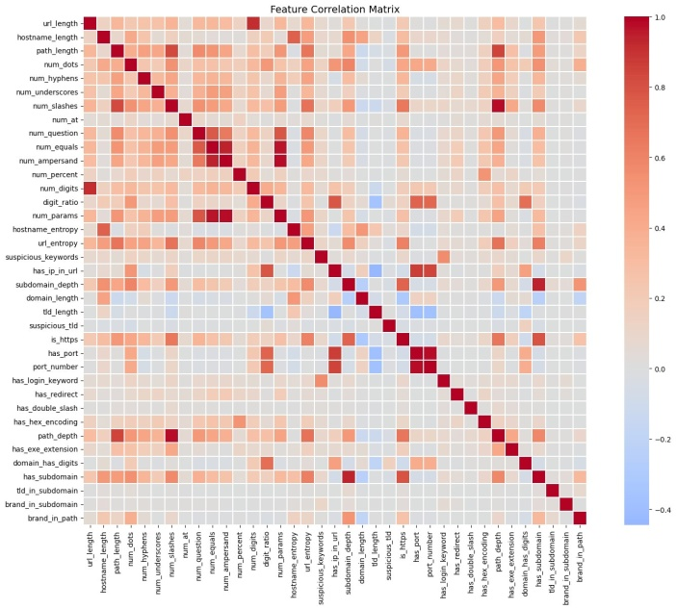
Fig. 3. Feature Correlation Matrix — Pearson correlations among all 34 URL features

E. Machine Learning Models
We evaluate six Machine Learning classifiers:
(1) Support Vector Machine with a special kind of kernel called RBF kernel;
(2) Gaussian Naive Bayes;
(3) Decision Tree with something called Gini impurity;
(4) Random Forest with 200 estimators;
(5) Logistic Regression, with a special kind of regularization called L2 regularization;
(6) XGBoost with 500 estimators, a learning rate of 0.05, a maximum depth of 7, subsample of 0.8 and colsample_bytree of 0.8.
All Machine Learning models are trained on features that have been standardized and evaluated on a test set that we held out using a kind of splitting called stratified train-test splitting to make sure the classes are balanced in the Machine Learning classifiers.
XGBoost is a way to make good predictions. It does this by creating a bunch of decision trees one after the other. Each new tree tries to fix the mistakes that the trees before it made. This helps to make sure the predictions are good and not closely fit, to the data.
The main goal of XGBoost is to make these predictions better and better.The XGBoost objective function is:
L(φ) = Σᵢ l(yᵢ, ŷᵢ) + Σₖ Ω(fₖ) where Ω(f) = γT + ½λ||w||²
Where l is a loss function that can be differentiated yᵢ is the label ŷᵢ is the predicted probability T is the number of leaves and λ γ are parameters that help prevent overfitting.
The gradient boosting framework helps XGBoost to understand relationships in URL structure that simple linear models and shallow tree models cannot understand. It enables XGBoost to capture high-order feature interactions, in URL structure.
F. SHAP Explainability
We want to make our model easy to understand and use it in life. So we use something called SHAP, which's a way to explain how our model works. SHAP looks at how each piece of information affects the models predictions. It does this in a way that's accurate, consistent and takes into account when information is missing. For each piece of information SHAP calculates a value that shows how important it is. This value is like an average of how much each piece of information contributes to the models predictions in all orders. This helps us see which information is most important overall and also understand each prediction. We make plots like beeswarm plots and bar charts to see which information has the biggest impact, on our XGBoost model. We use SHAP to get these plots and understand our XGBoost model better.
IV. Results and Discussion
This part of the report looks at how the six machine learning models did when we used them with our URL dataset. We also checked the XGBoost model to see how it worked, using tools that help us understand what the model is doing. We used these tools to get an idea of what the XGBoost model is doing and why it is making certain decisions. The XGBoost model is one of the six machine learning models that we trained on our URL dataset.
A. Algorithm Comparison
Table I shows how well each algorithm did on the test set that we did not use to train them. The XGBoost algorithm does the job it gets things right 99.99 % of the time. It also has a good AUC-ROC score of 0.9992. This means the XGBoost algorithm is better than all the methods we tried it is good at getting the right answer. It can tell things apart very well. The XGBoost algorithm is the best at accuracy. It is also the best, at telling things apart.

TABLE I. Performance Comparison of ML Algorithms

Fig. 4 Shows a comparison of Accuracy, F1-Score and AUC-ROC metrics.All algorithms do well with accuracy over 99.6% because the features used are very good at telling things apart. XGBoost does the best in all three areas. The difference in performance is biggest in accuracy, where XGBoost gets 99.99%. Svm gets 99.64%.This shows that XGBoost, which uses gradient boosting is better at dealing with the boundary between harmless and harmful URLs, in the feature space. XGBoost handles the decision boundary of benign and malicious URLs well. The engineered features help XGBoost and other algorithms to achieve accuracy.
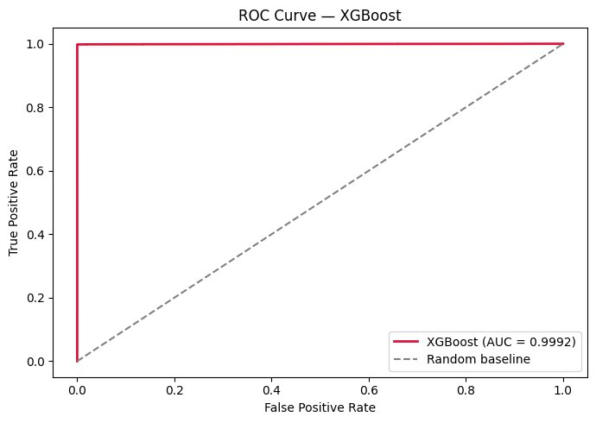
Fig. 4. Algorithm Comparison — Accuracy, F1-Score, and AUC-ROC across six classifiers.

B. XGBoost Confusion Matrix
Algorithm | Accuracy | Precision | Recall | F1-Score | AUC-ROC
SVM | 99.64% | 0.9921 | 0.9897 | 0.9909 | 0.9989
Naive Bayes | 99.90% | 0.9981 | 0.9969 | 0.9975 | 0.9989
Decision Tree | 99.94% | 0.9989 | 0.9981 | 0.9985 | 0.9989
Random Forest | 99.95% | 0.9992 | 0.9984 | 0.9988 | 0.9990
Logistic Reg. | 99.95% | 0.9993 | 0.9985 | 0.9989 | 0.9990
XGBoost ★ | 99.99% | 0.9997 | 0.9979 | 0.9988 | 0.9992
The XGBoost model is really good at telling the difference between bad things. If we look at the results in Figure 5 we can see that it got most of them right. There were 61,274 times when it said something was good. It was actually good. There were 15,285 times when it said something was bad. It was actually bad. There were only 4 times when it said something was bad and it was actually good. There were 34 times when it said something was good. It was actually bad.
The fact that it only missed 34 things out of 15,319 is a big deal, for security. This is because when the XGBoost model misses something that means it did not detect a threat that could hurt people. The XGBoost model missed than one percent of the bad things, which is really good. The XGBoost model is doing a job of finding the bad things and keeping people safe.
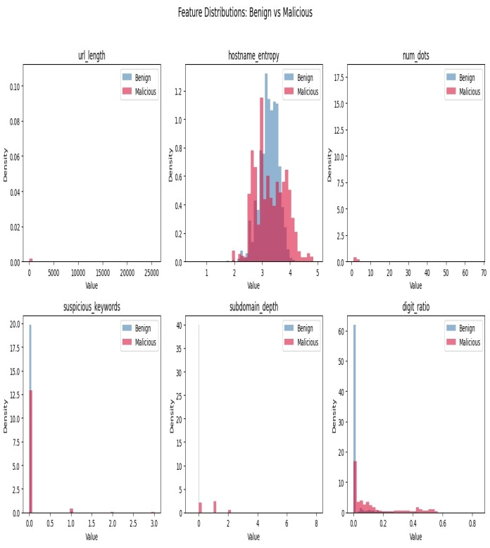
Fig. 5. XGBoost Confusion Matrix on the held-out test set.
C. ROC Curve Analysis
The XGBoost model has a graph that shows how well it works, which is called the Receiver Operating Characteristic (ROC) curve and you can see it in Fig. 6. This curve goes up fast to the top left corner. The XGBoost model is really good at finding the URLs with almost all of them being found when it is not finding many good URLs by mistake.
The Area under the Curve is 0.9992, which means the XGBoost model is 99.92 % sure it can tell the difference between an URL and a good one. This shows that the XGBoost model and the features we used are very good at telling the URLs from the good ones. The XGBoost model is very good, for this job.
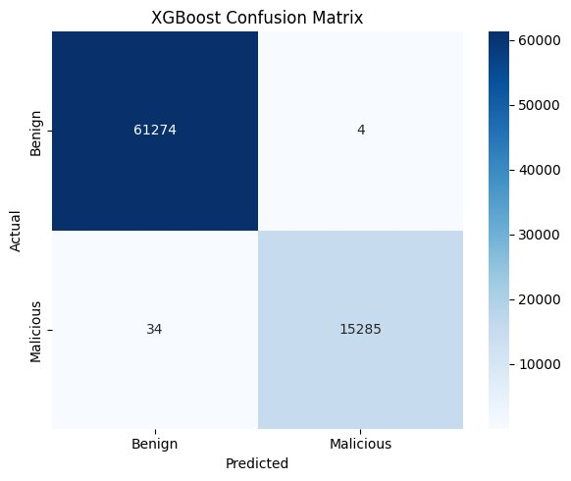
Fig. 6. ROC Curve for the XGBoost model (AUC = 0.9992).
D. SHAP Feature Importance Analysis
Figure 7 shows us the SHAP feature importance. It ranks the features by how important they're on average. The feature that stands out the most is path_length. It has an absolute SHAP value of 5.08. This is than five times the value of the next feature, which is url_length. The mean absolute SHAP value of url_length is 0.92. This makes sense because we know that bad URLs often have long paths. These paths can have base64-encoded parameters or random segments that help them avoid being caught by filters. The top ten features that are important, for SHAP are: path_length, url_length, is_https num_slashes, url_entropy, hostname_entropy, domain_length, subdomain_depth, num_hyphens and tld_length.

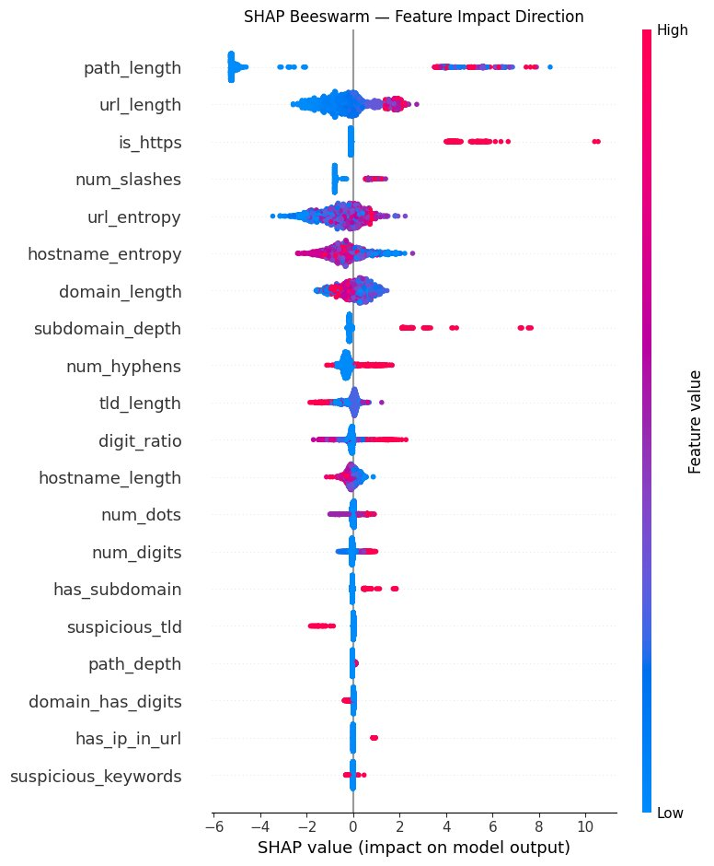
Fig. 7. SHAP Global Feature Importance — mean absolute SHAP values for all 20 top features.
The SHAP beeswarm plot, which is Figure 8 gives us information about what is going on. When we look at the path_length we see that the high feature values, which are the dots are linked to very positive SHAP values. This means they are pushing towards a prediction. This tells us that long URL paths are a sign of something being malicious. On the hand when we look at the is_https values we see that high values are linked to negative SHAP values. This means they are pushing towards a prediction. This shows us that legitimate sites use HTTPS more, than sites that are set up quickly to do things.
The url_entropy feature is also very interesting. It has a bimodal SHAP distribution, which means it has two peaks. We see that both low and very high entropy values are linked to malicious URLs. The low entropy values are linked to obfuscation patterns. The high entropy values are linked to DGA-generated domains. The SHAP beeswarm plot and the url_entropy feature are both telling us about the SHAP values and the url_entropy feature.
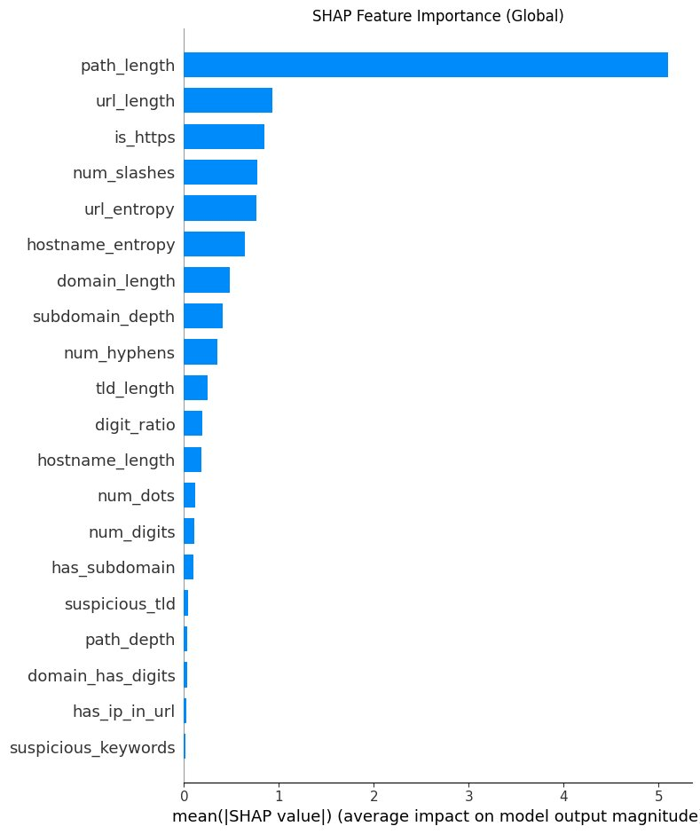
Fig. 8. SHAP Beeswarm Plot — feature impact direction and magnitude for XGBoost.
E. Discussion
Our results are very important for detecting websites.
* First our test shows that XGBoost is almost perfect with 99.99% accuracy when it only looks at parts of a websites address. This is a deal because it means we can use simple details about a websites address to get good results. These details are much easier to get than what deep learning models need. They work just as well.
* Second when we looked closer at how our model works we found that one simple detail. How long the websites address path is. Is the indicator of whether a website is bad or not. So if we want to make a system to detect bad websites we should focus on this detail more than anything else. The path length is a factor in determining if a website is malicious and our model relies on it heavily. The results show that XGBoost and path length are crucial, for detecting URLs.
The thing that really stands out is the low rate of false negatives, which is only 0.22 %. This is a deal when it comes to cybersecurity. You see, when we are talking about cybersecurity it is much worse to have negatives, which are bad links that we miss than false positives, which are good links that we block by mistake. Our system is really good at not missing the links and it is just as good as or even better, than other systems that use a lot of computer power.
The analysis of the features also shows that many of the things we look at when checking URLs are of similar so we might be able to make the system even smaller and more efficient by picking the most important ones. This is important because when we are using the system in time we need it to work well even when it does not have a lot of computer power to use. The cybersecurity system and the URL features and the cybersecurity applications all need to work to make this happen.
Fifth, when we look at how the algorithms compare we see something. All six of the classifiers are very good at getting the answer but when we look really closely there are some big differences. The algorithms called SVM and Naive Bayes are actually pretty simple. They do really well when it comes to figuring out what is real and what is not. This tells us that the things we are looking at can be separated into groups easily.. When we look at the situations that are not normal the ensemble methods, like Random Forest and XGBoost do a better job. These situations are like the cases where someone is trying to trick us in a new and sneaky way and it is hard to tell if it is real or not. The ensemble methods are better, at catching these cases.
V. Conclusion and Future Work
This paper is about using machine learning to find URLs early. We made a system that looks at 35 things about each URL to figure out if it is bad. We tried six machine learning methods. SVM, Naive Bayes, Decision Tree, Random Forest, Logistic Regression and XGBoost. On a big set of URLs over 385,000. The XGBoost method we came up with is really good it gets it right 99.99 % of the time. It also gets a F1-score of 0.9988 and AUC-ROC of 0.9992, which is better than the other methods. The good thing, about our method is that it does not need to look at the page or connect to the internet to work.
We used something called SHAP to see what makes a URL bad. It said that how long the URL path is is the important thing. Then it is how long the whole URL is, if it uses https how many slashes it has and how mixed up the URL is. This information can help people who protect networks from URLs.
The system they are talking about looks at the website address, which makes it really good for using right away in things like security gateways and email scanners and browser extensions and network monitoring systems. The system is very good at finding links and it does not make many mistakes. It misses links only a tiny bit of the time which is about 0.22 % and it gets things wrong and says a link is bad when it is actually okay only about 0.007 % of the time. This means that people who use the system will be safe, from links and they will not have to deal with a lot of false alarms when they are just trying to look at regular websites.
Future work on our model will focus on promising areas:
1. The model will get better over time. This means it can keep up with bad URL patterns without having to start from scratch. Cybersecurity threats are always changing,. This is important.
2. We plan to add information about how things work. For example we will look at where an IP addresss from who registered a website and how a server responds. This will help us catch fake websites that are good at hiding.
3. We need to make sure our model is safe. Some people try to trick it on purpose by creating URLs that look okay. Are actually bad. We must protect against this.
4. The model will be able to tell the difference between types of URLs. For instance it will identify URLs with viruses spam URLs and URLs that have been taken over. This way we can take action against them.
5. We will turn the model into a service that other systems can use. This includes firewalls and email security systems. It will help keep people safe online.
6. We are working on a way for many organizations to improve the model together. They won't have to share information about the URLs they've found. This is important because people don't want to share that information.
We will make the model better. The model will detect URL patterns. Be a key tool, for cybersecurity. The model will help protect people from URLs.

References
[1] M. Aljabri et al., "Detecting malicious URLs using machine learning techniques: review and research directions," IEEE Access, vol. 10, pp. 121395–121417, 2022. DOI: 10.1109/ACCESS.2022.3222307
[2] A. Weshahi, F. Dwaik, M. Khouli, H.I. Ashqar, and A. Shatnawi, "IoT-enhanced malicious URL detection using machine learning," in Proc. International Conference on Advanced Computing and Applications (ACANAC), Springer, 2024.
[3] M. Swarnkar, N. Sharma, and H.K. Thakkar, "Malicious URL detection using machine learning," Studies in Computational Intelligence, vol. 1065, pp. 199–216, 2023. DOI: 10.1007/978-981-19-6290-5_11
[4] S. Das Guptta, K.T. Shahriar, H. Alqahtani, D. Alsalman, and I.H. Sarker, "Modeling hybrid feature-based phishing websites detection using machine learning techniques," Annals of Data Science, vol. 11, no. 1, pp. 217–242, 2024. DOI: 10.1007/S40745-022-00379-8
[5] A. Karim, M. Shahroz, K. Mustofa, S.B. Belhaouari, and S.R.K. Joga, "Phishing detection system through hybrid machine learning based on URL," IEEE Access, vol. 11, pp. 36805–36822, 2023.
[6] R. Alazaidah et al., "Website phishing detection using machine learning techniques," Journal of Statistics and Applications in Probability, vol. 13, no. 1, pp. 119–129, 2024.
[7] M. Alsaedi, F.A. Ghaleb, F. Saeed, J. Ahmad, and M. Alasli, "Cyber threat intelligence-based malicious URL detection model using ensemble learning," Sensors, vol. 22, p. 3373, 2022.
[8] S.S. Roy, A.I. Awad, L.A. Amare, M.T. Erkihun, and M. Anas, "Multimodel phishing URL detection using LSTM, bidirectional LSTM, and GRU models," Future Internet, vol. 14, no. 11, p. 340, 2022. DOI: 10.3390/FI14110340
[9] Z. Alshingiti, R. Alaqel, J. Al-Muhtadi, Q.E.U. Haq, K. Saleem, and M.H. Faheem, "A deep learning-based phishing detection system using CNN, LSTM, and LSTM-CNN," Electronics, vol. 12, no. 1, p. 232, 2023. DOI: 10.3390/ELECTRONICS12010232
[10] R. Liu, Y. Wang, Z. Guo, H. Xu, Z. Qin, W. Ma, and F. Zhang, "TransURL: Improving malicious URL detection with multi-layer Transformer encoding and multi-scale pyramid features," Computer Networks, vol. 253, p. 110707, 2024.
[11] M.-Y. Su and K.-L. Su, "BERT-based approaches to identifying malicious URLs," Sensors, vol. 23, p. 8499, 2023.
[12] M. Elsadig, A.O. Ibrahim, S. Basheer, M.A. Alohali, S. Alshunaifi, H. Alqahtani, N. Alharbi, and W. Nagmeldin, "Intelligent deep machine learning cyber phishing URL detection based on BERT features extraction," Electronics, vol. 11, p. 3647, 2022.
[13] H. Kibriya, A. Siddiqa, W.Z. Khan, and M.K. Khan, "Towards safer online communities: deep learning and explainable AI for hate speech detection and classification," Computers & Electrical Engineering, vol. 116, p. 109153, 2024.
[14] T.L. Halili, A. Halili, K. Vishi, and B. Rexha, "NoPhish: Efficient Chrome extension for phishing detection using machine learning techniques," arXiv: Cryptography and Security, 2024.
[15] M. Sanchez-Paniagua, E.F. Fernandez, E. Alegre, W. Al-Nabki, and V. Gonzalez-Castro, "Phishing URL detection: A real-case scenario through login URLs," IEEE Access, vol. 10, 2022.
[16] S.D. Gupta, K.T. Shahriar, and I.H. Sarker, "Phishing detection using CNN with Brown Bear optimization," in Proc. 2023 International Conference, 2024.
[17] S.R. Abdul Samad, A. Abdullah, M.F. Abdollah, A.A. Mutalib, and S.A.M. Noah, "Analysis of the performance impact of fine-tuned machine learning model for phishing URL detection," Electronics, vol. 12, no. 7, 2023.
[18] A.M. Salih et al., "A perspective on explainable artificial intelligence methods: SHAP and LIME," Advanced Intelligent Systems, vol. 7, p. 2400304, 2025.
[19] A. Saxena, A. Arora, S. Saxena, and A. Kumar, "Analysis of web security flaws and machine learning approaches for URL classification," in Proc. 2022 International Conference on Intelligent Computing and Communication, 2022.
[20] C. Catal, G. Giray, B. Tekinerdogan, S. Kumar, and S. Shukla, "Applications of deep learning for phishing detection: a systematic literature review," Artificial Intelligence Review, vol. 64, no. 6, 2022.
[21] Y. Gu et al., "From past to present: A survey of malicious URL detection techniques, datasets and code repositories," arXiv:2504.16449, 2025.
[22] S. Aslam, H. Aslam, A. Manzoor, H. Chen, and A. Rasool, "AntiPhishStack: LSTM-based stacked generalization model for optimized phishing URL detection," Symmetry, vol. 16, no. 2, 2024.
[23] I. Kara, M. Ok, and A. Ozaday, "Characteristics of understanding URLs and domain names features: The detection of phishing websites with machine learning methods," IEEE Access, 2022.
[24] D. Sahoo, C. Liu, and S.C.H. Hoi, "Malicious URL detection using machine learning: A survey," arXiv:1701.07179, 2017.
[25] Anti-Phishing Working Group (APWG), "Phishing Activity Trends Report, Q4 2023," APWG, 2024. [Online]. Available: https://apwg.org/trendsreports/

